# EXPLORATORY DATA ANALYSIS FOR PRODUCT RECOMMENDATION PROJECT

#COUNT OF INTERACTION TYPE

sns.set(style="whitegrid")

plt.figure(figsize=(8, 5))

sns.countplot(x='interaction_type', data=df, palette='viridis')

plt.title('Distribution of Interaction Types')

plt.ylabel('Count')

plt.show()

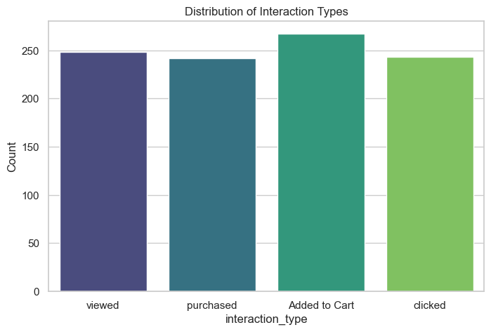

# INTERACTION SCORE DISTRIBUTION

plt.figure(figsize=(8, 5))

sns.histplot(df['interaction_score'], kde=True, bins=30, color='blue')

plt.title('Distribution of Interaction Scores')

plt.xlabel('Interaction Score')

plt.ylabel('Frequency')

plt.show()

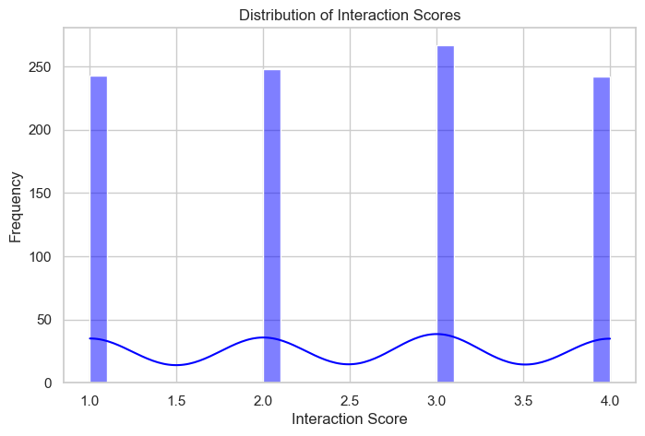

#TOP 10 MOST INTERACTED PRODUCTS

plt.figure(figsize=(10, 6))

top_products = df['product_id'].value_counts().head(10)

sns.barplot(x=top_products.index, y=top_products.values, palette='Blues_d')

plt.title('Top 10 Most Interacted Products')

plt.xlabel('Product ID')

plt.ylabel('Interaction Count')

plt.xticks(rotation=45)

plt.show()

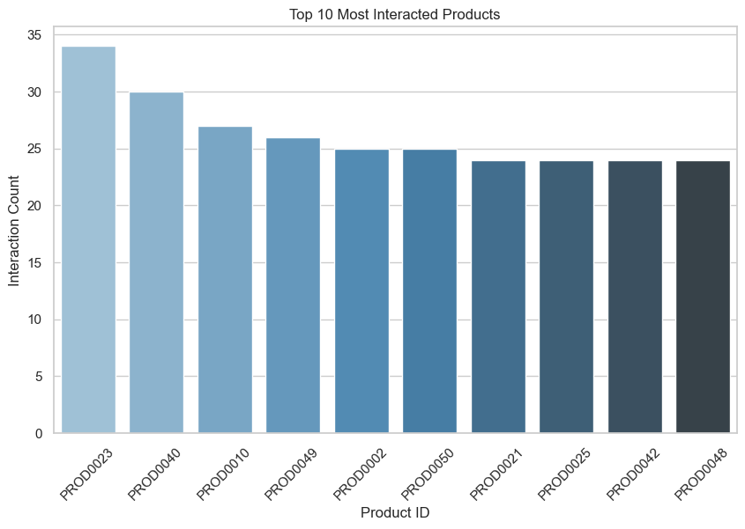

#TOP 10 MOST INTERACTED CUSTOMERS

plt.figure(figsize=(10, 6))

top_customers = df['customer_id'].value_counts().head(10)

sns.barplot(x=top_customers.index, y=top_customers.values, palette='Blues_d')

plt.title('Top 10 Most Interacted Customers')

plt.xlabel('Customer ID')

plt.ylabel('Interaction Count')

plt.xticks(rotation=45)

plt.show()

